**Usecase diagram for Employement service**

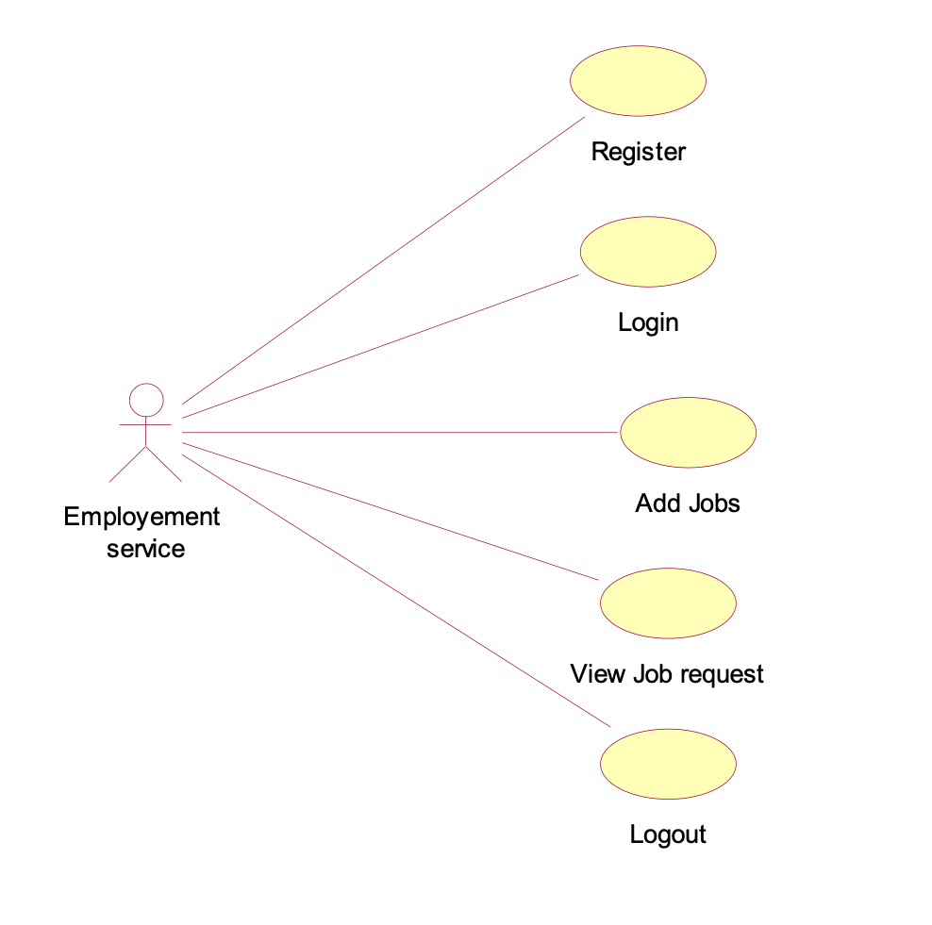

**For Job seeker:**

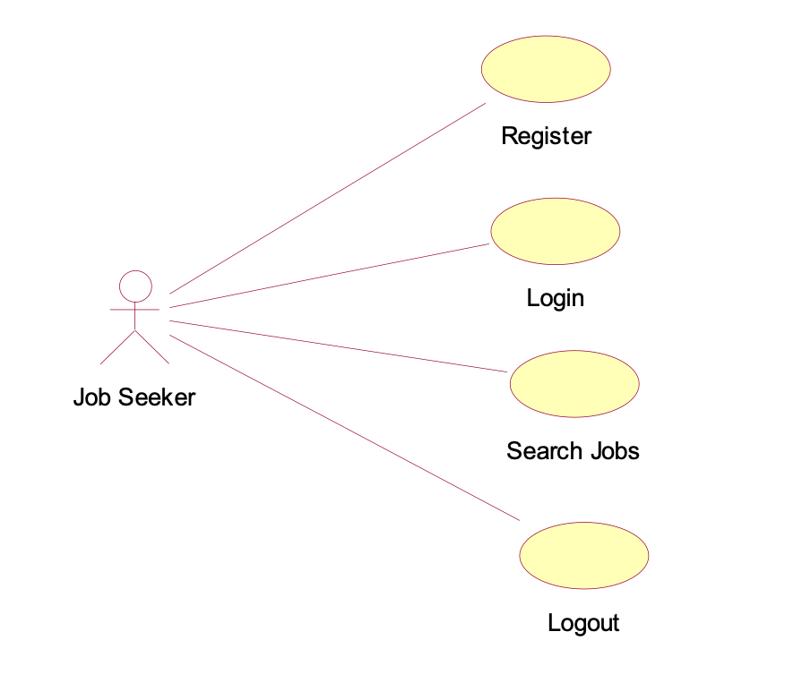

**Class diagram:**

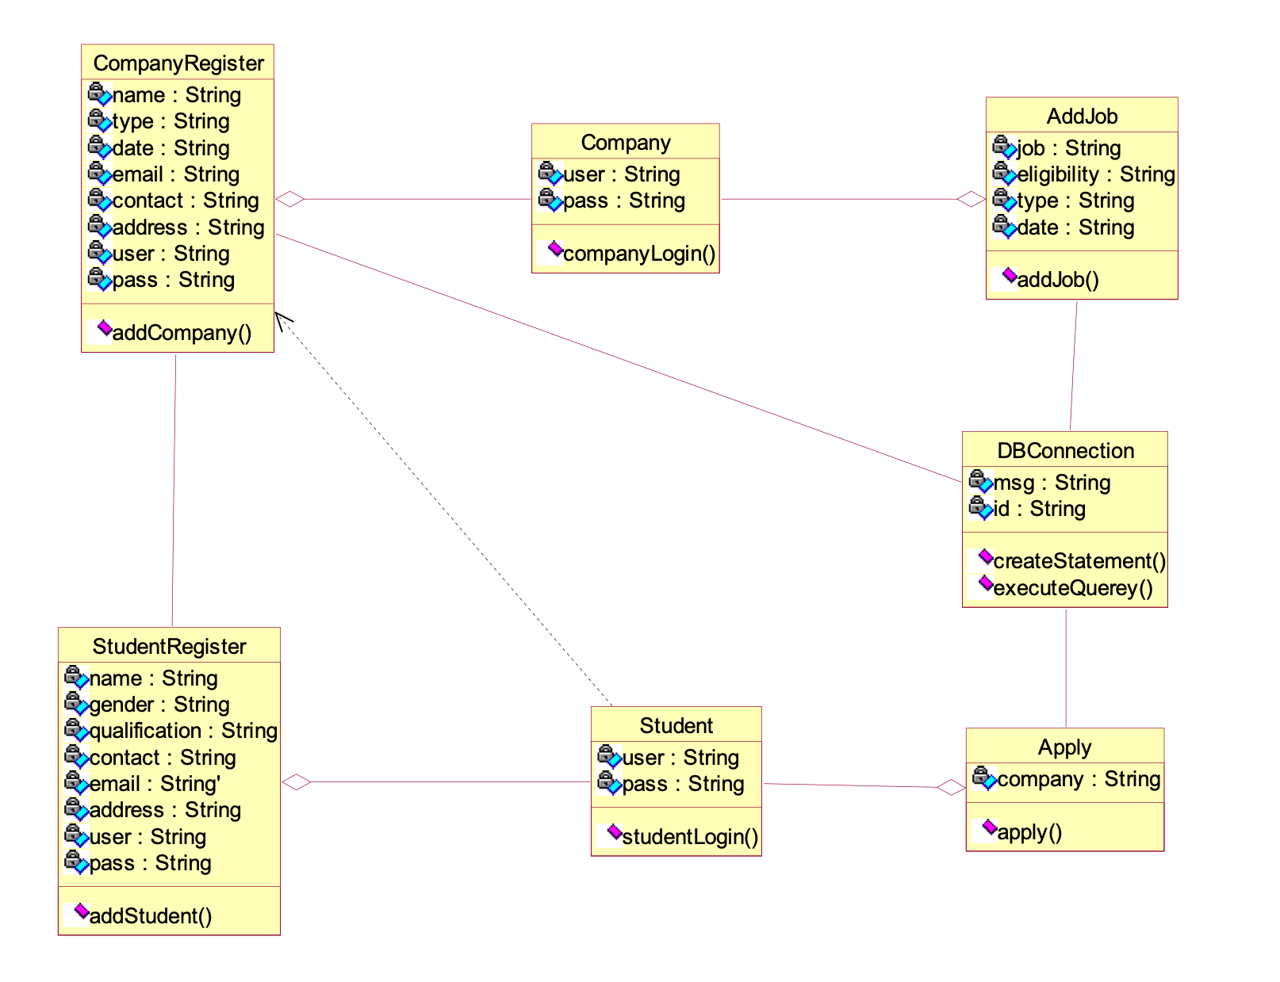

**Component diagram:**

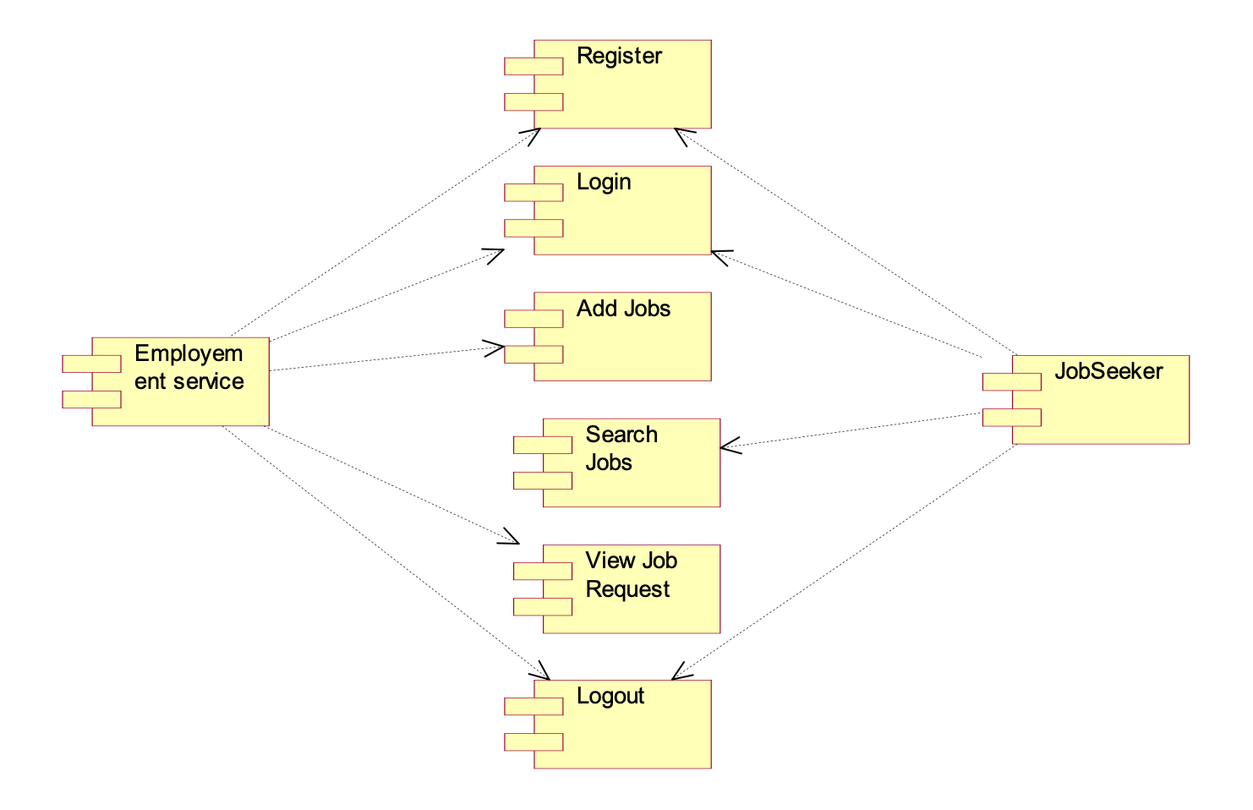

**Deployment diagram:**

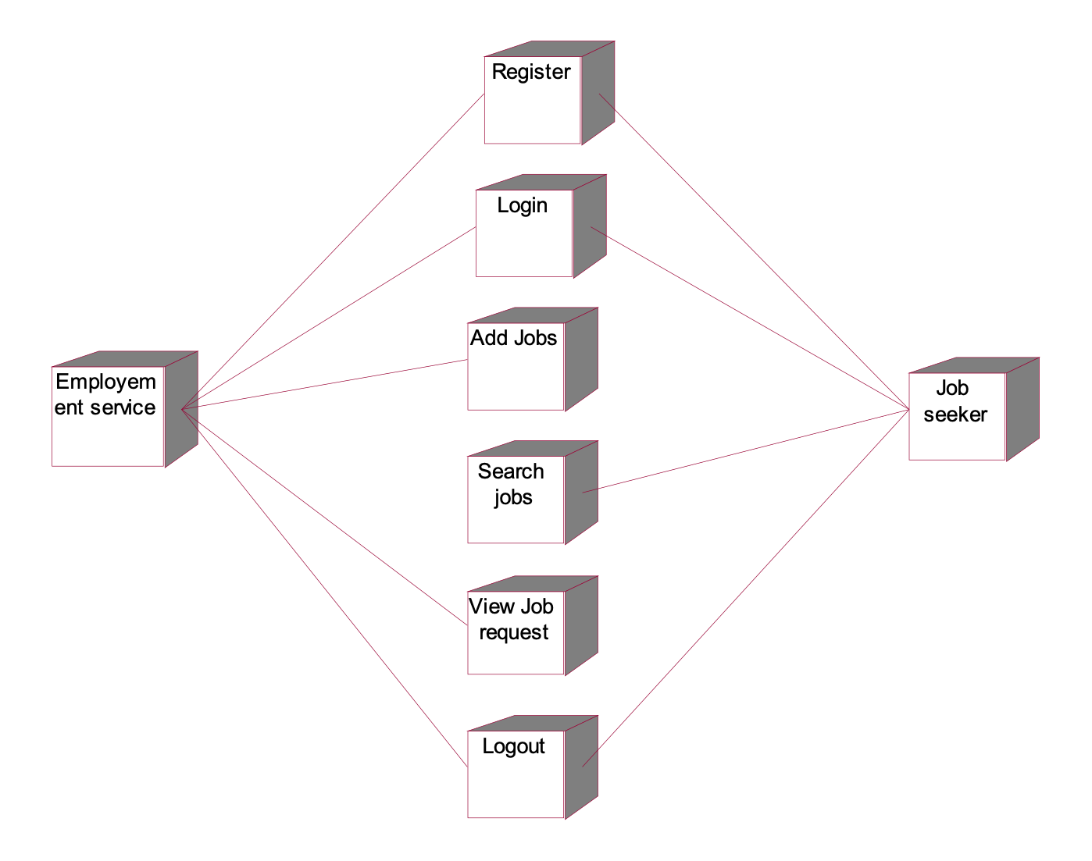

**Sequence diagram:**

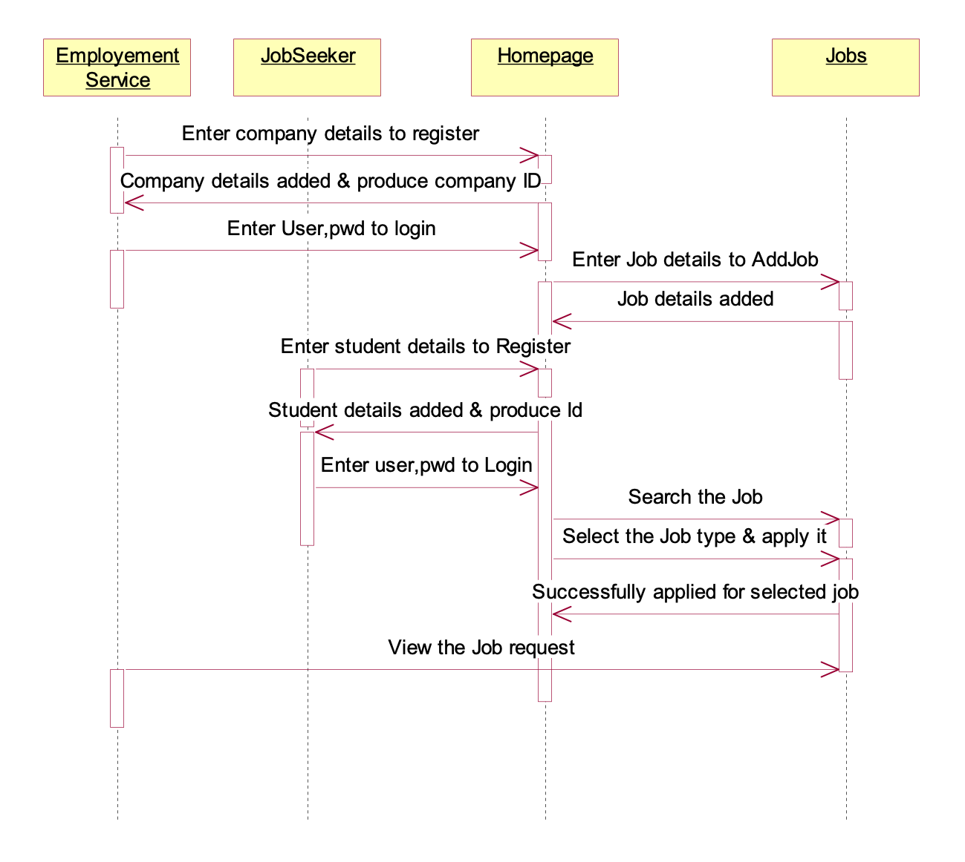

**Collaboration diagram:**

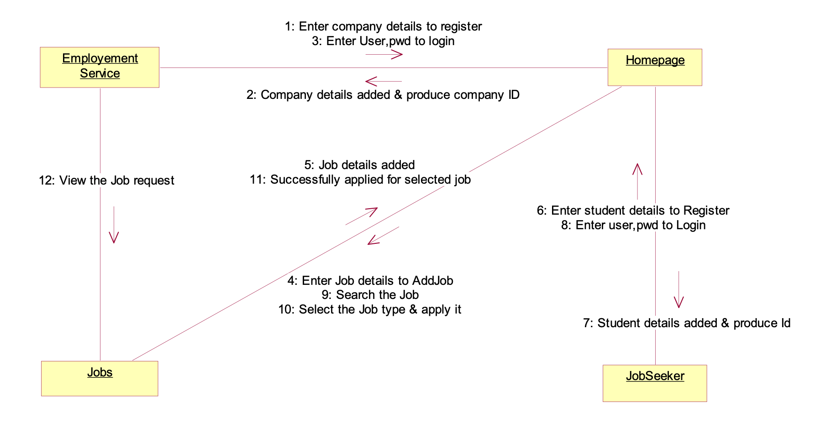

**Activity diagram:**

Search Jobs

Logout

View Job Request

Add Jobs

Login

Register

Employement service Job seeker